Phase 6 - Project Testing Phase

The implemented UI Policy and Client Scripts are tested using different Incident conditions
.
Test 1 - Mandatory Enforcement

A new Incident is opened using Incident -> Create New. Impact is set to High and Assigned To is left empty, then Submit is clicked. The system does not save the Incident and an error message is displayed.

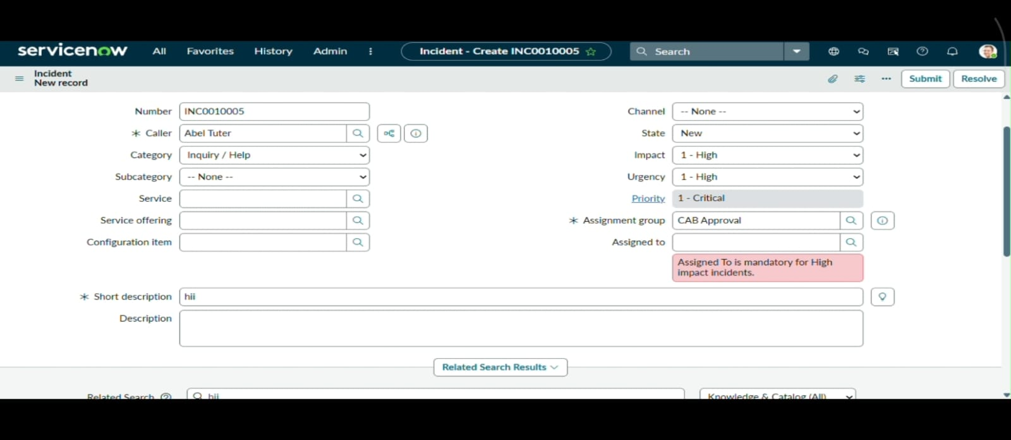
Mandatory Field Validation Message

Test 2 - Successful Save

A valid user is selected in the Assigned To field and the Incident is submitted. The record is saved successfully without any error.
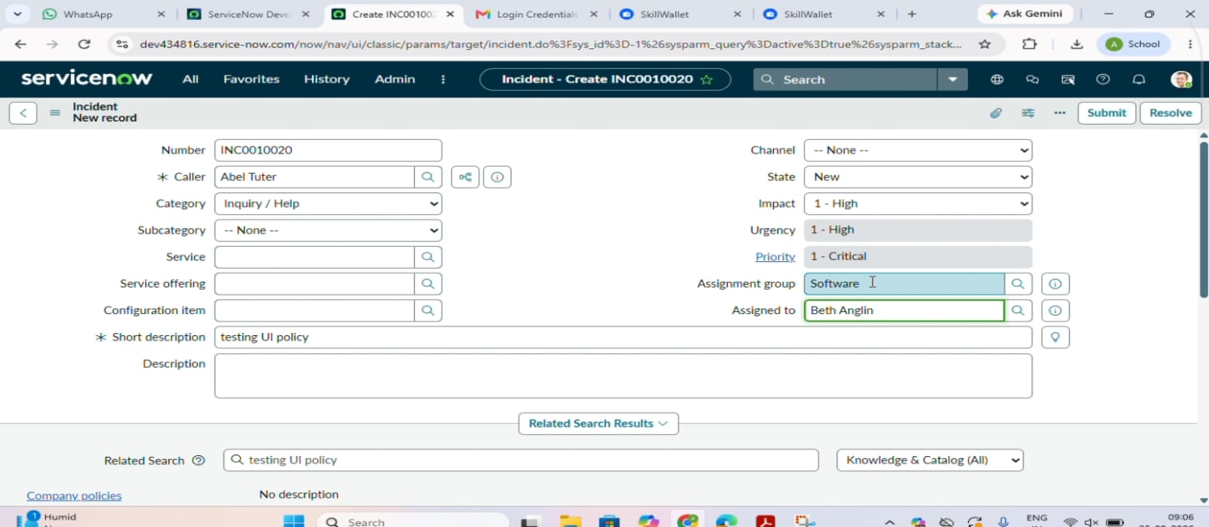

Successfully Saved Incident Record
Test 3 - Reverse Condition

An existing High Impact Incident is opened and the Impact is changed from High to Medium. Assigned To is no longer mandatory and Urgency becomes editable. The record is submitted successfully, which confirms that Reverse if false works correctly.

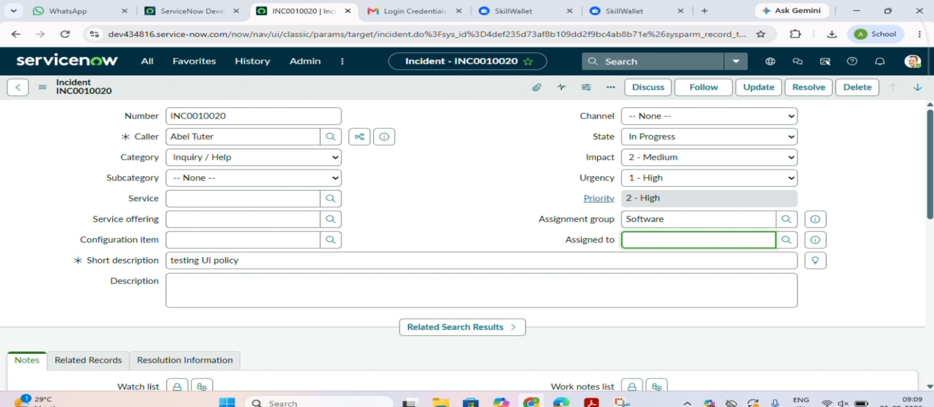

Reverse Condition Verification

Test 4 - List Edit Blocking

The Incident list is opened using Incident -> All and the State field of a record is double-clicked. An alert message appears and the original State value remains unchanged.
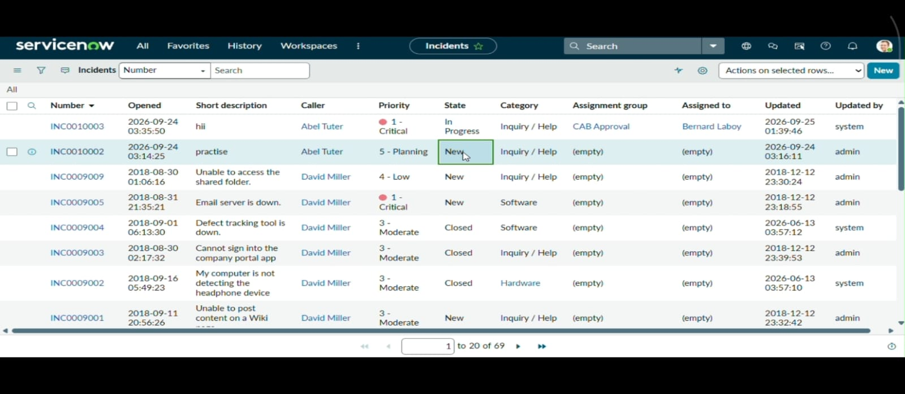
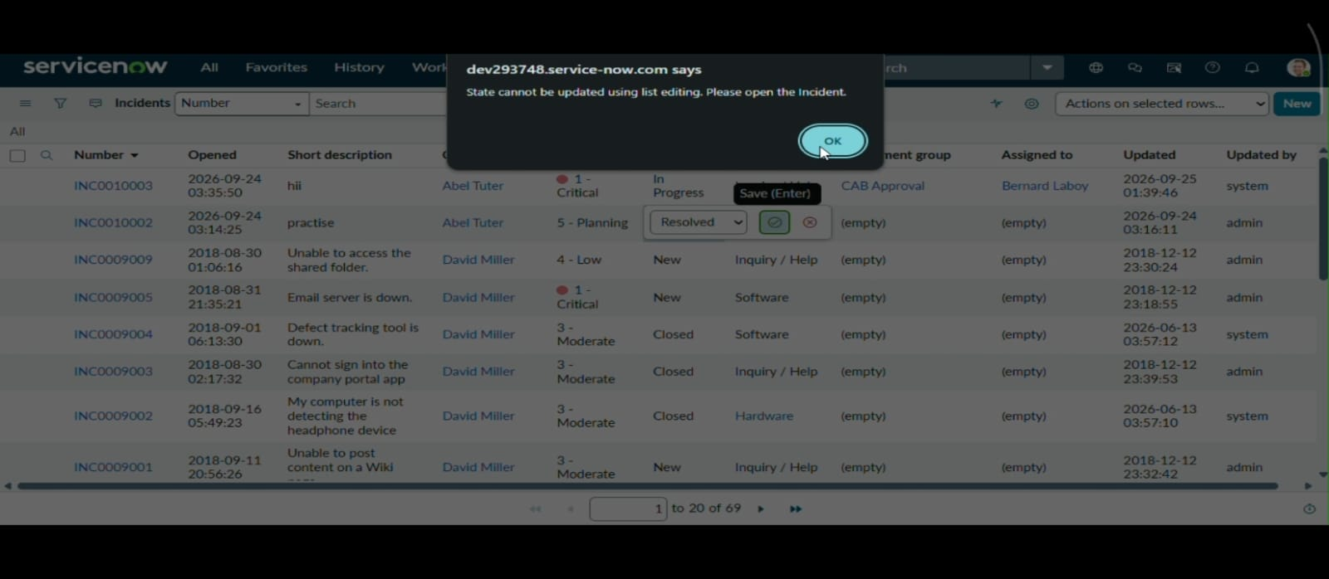

State List Edit Blocking

Test 5 - Form-Based Update

The same Incident is opened through the form, the State is changed and Update is clicked. The record is saved successfully, which shows that the restriction applies only to list editing.

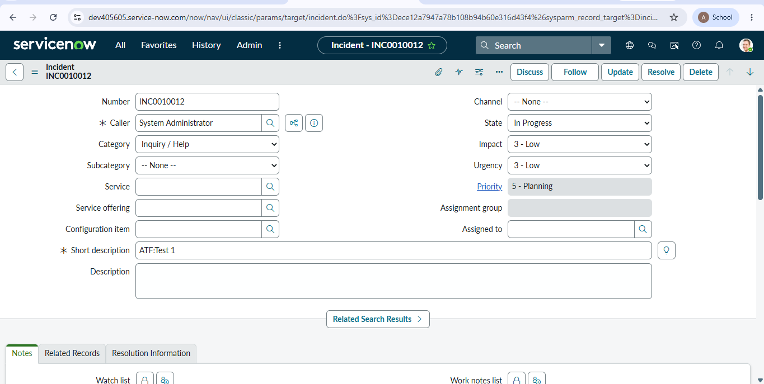

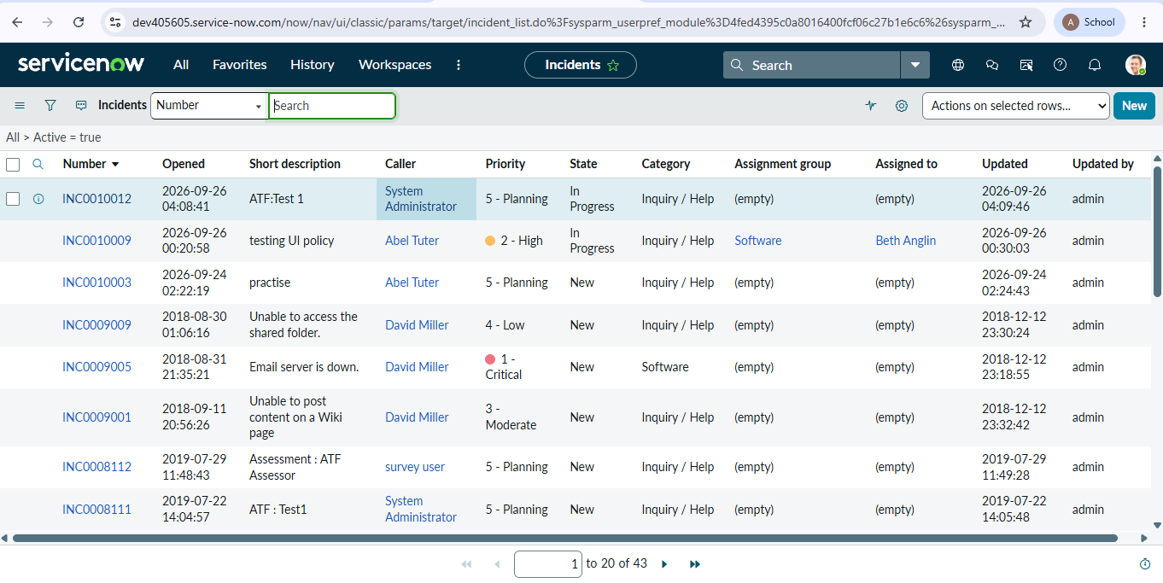
Successful Form-Based State Update

Testing Summary

Test Case | Expected Result | Status
High Impact with Assigned To empty | Incident should not be saved | Passed
High Impact with Assigned To filled | Incident should save successfully | Passed
Impact changed from High to Medium | Previous restrictions should be removed | Passed
State changed from Incident list | State change should be blocked | Passed
State changed from Incident form | State change should be saved | Passed
Impact changed to High | Urgency should be set to High | Passed

The test results show that all the configured conditions are working properly.

